* Download tool from https://github.com/tzutalin/labelImg/files/2638199/windows_v1.8.1.zip
* Extract the zip file
* Open the folder, double click on labelImg.exe
* Load images directory by clicking ‘Open Dir’ button

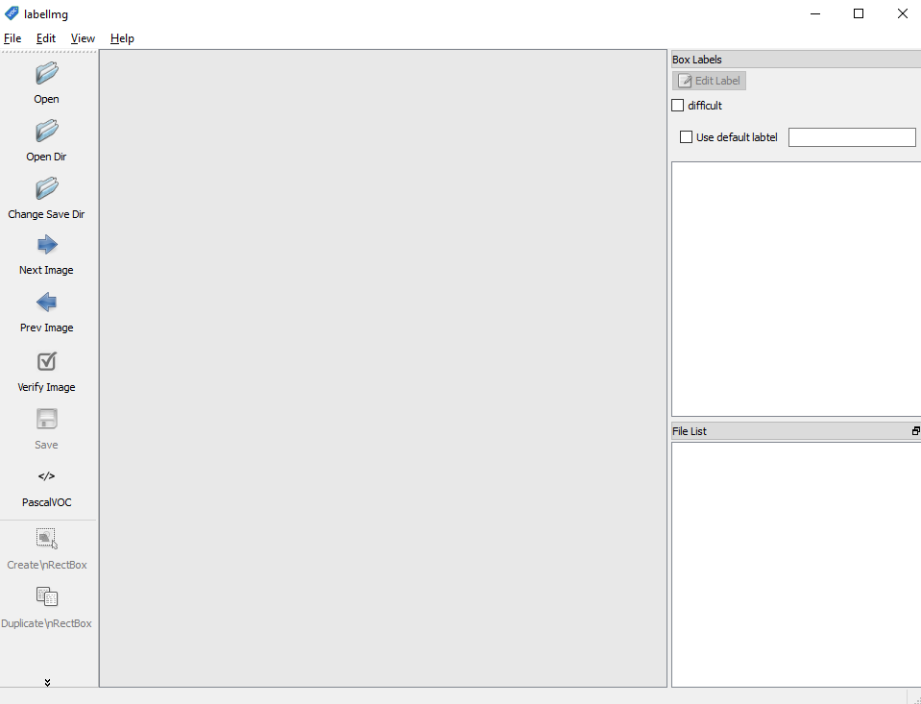

* Once image directory is selected, another dialog box will be opened automatically
  + The annotations you will do will be saved in a file (.txt), create a new folder with name labels and select it
* Annotations can be saved in two formats either Yolo or Pascal format, change the format to YOLO from the left pan of tool(see above image for reference)
* Press ‘w’ from keyboard to start drawing the bounding box

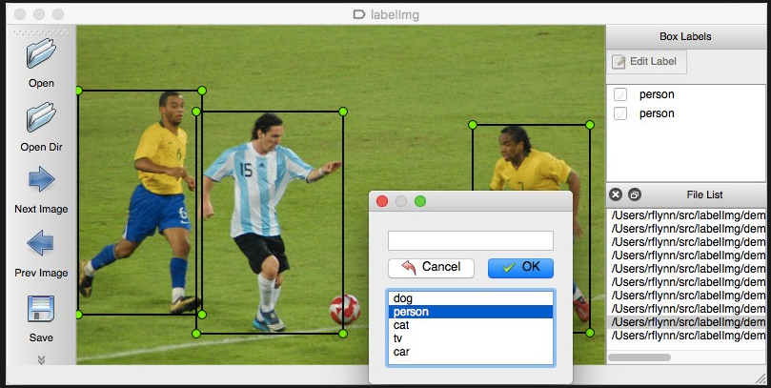

* Drag the mouse cursor from the start of object till end
* Draw tight bounding boxes around the object
* Give the required title to the object
* Press ‘s’ from keyboard to save the annotations
* Press ‘d’ from keyboard for next image
* Press ‘a’ from keyboard for previous image
* After doing one image press ‘d’ to move to the next image and then check previous image by pressing ‘a’ to make sure everything is working fine
* Also read instructions at https://github.com/tzutalin/labelImg